Living Degraded Soils

Visual examples and descriptions

This document provides examples of Degraded Soils.

Deep Gullies – Water Erosion
Shows deep channels formed by running water, leading to topsoil loss.
🔗 Image link: https://tse4.mm.bing.net/th/id/OIP.fSCbJ3roY8SqAA1B1kcOigHaFf?pid=Api
Source: Alamy

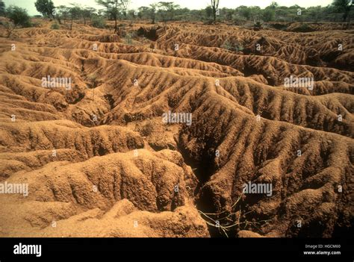

Exposed Roots – Topsoil Loss
Roots visible due to erosion removing upper soil layers.
🔗 Image link: https://tse2.mm.bing.net/th/id/OIP.B3PzYP_f6KJ3dn9Kfm6EbQHaEK?pid=Api
Source: Freepik

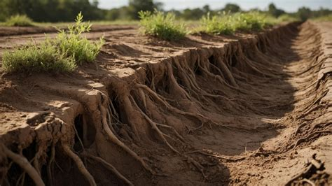

Cracked Dry Soil – Compaction & Drought
Dry, compacted surface with poor vegetation cover.
🔗 Image link: https://tse2.mm.bing.net/th/id/OIP.aickSJogNnlbnBJzpO9H7gHaE8?pid=Api
Source: Alamy

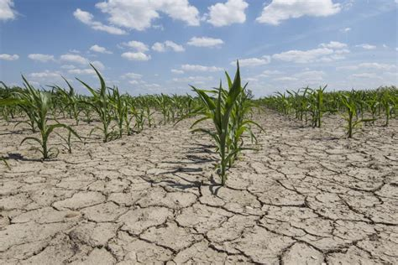

Soil Pits & Tracks – Tillage Damage
Deep marks from heavy machinery causing compaction and disturbance.
🔗 Image link: https://tse1.mm.bing.net/th/id/OIP.vGBWkQVNEjEBAnp5LT4xjwHaEK?pid=Api
Source: Stock Image
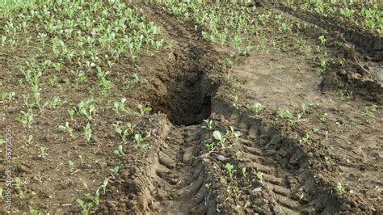

Living Helthy Soils

Visual examples and descriptions

This document provides examples of Healthy Soils.

Rich Organic Soil under Sunlight
Dark, crumbly soil rich in organic matter, well-aerated and naturally lit.
🔗 Image link: https://tse1.mm.bing.net/th/id/OIP._-rXWNJVNUTFsWgjyQBkHgHaEk?pid=Api
Source: Dreamstime


Soil with Roots and Microorganisms
Healthy soil with visible plant roots and microbial activity—indicators of soil vitality.
🔗 Image link: https://tse4.mm.bing.net/th/id/OIP.0qE6ZJJZenBv9O8soXOXEAHaEK?pid=Api
Source: Dreamstime
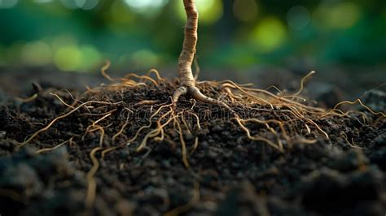

Sprout Emerging from Fertile Soil
A young seedling breaking through moist soil, showing conditions ideal for plant growth.
🔗 Image link: https://tse1.mm.bing.net/th/id/OIP.n8HcVdORlTcBQ4f4O9QVZQHaER?pid=Api
Source: Hobby Farms


Nutrient-Rich Soil with Young Plant
Soil supporting early plant development, with a good balance of moisture and nutrients.
🔗 Image link: https://tse3.mm.bing.net/th/id/OIP.rEz3JmoLzCyuhje9QUaJ_AHaD3?pid=Api
Source: Shutterstock


