Symmetry Glossary

with real visual examples (or image links)

This glossary was created to support the exploration of symmetry in mathematics and the natural world. It includes key terms related to symmetry, each accompanied by a clear definition, a practical example, and a visual link to help students understand the concept more concretely.
Symmetry is all around us—in art, nature, architecture, and design. Through this glossary, learners will be able to identify and describe different types of symmetry, such as reflection, rotational, and translational symmetry, as well as related concepts like tessellation and geometric transformations.
Use this resource to build vocabulary, support class discussions, and guide visual observations in both mathematical and interdisciplinary contexts.

Symmetry
Definition: A figure has symmetry if one half is a mirror image of the other half.
Visual Example: Example: A butterfly – if you fold it down the middle, both sides match.
🔗 Image Link: https://tse3.mm.bing.net/th/id/OIP.bkbEduZBDC0qpZWTjkDoCwHaHa?pid=Api

Line of Symmetry (Axis of Symmetry)
Definition: An imaginary line that divides a figure into two equal and symmetrical parts.
Visual Example: Example: A heart shape has one vertical line of symmetry.
🔗 Image Link: https://tse3.mm.bing.net/th/id/OIP.Yd3QsAqBf8uHqzsVHXmfIAHaGD?pid=Api

Reflection (Mirror Symmetry)
Definition: A transformation where a shape is flipped over a line, creating a mirror image.
Visual Example: Example: The letter 'A' reflected over a vertical line still forms an 'A'.
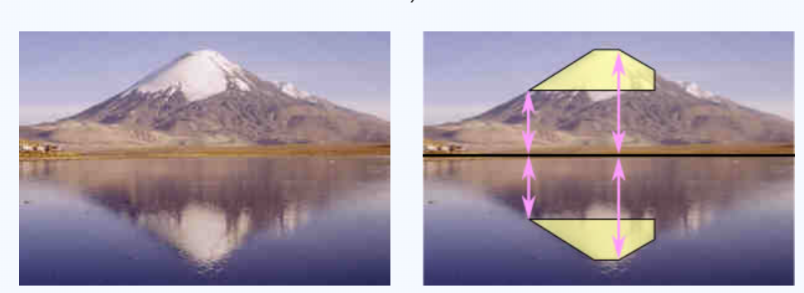

Rotational Symmetry
Definition: A figure has rotational symmetry if it looks the same after a certain amount of rotation (less than a full turn).
Visual Example: Example: A regular triangle (equilateral) looks the same after a 120° rotation.
🔗 Image Link: https://tse4.mm.bing.net/th/id/OIP.hYba9a_LJP4zVFvqIylTNgHaHa?pid=Api

Translational Symmetry
Definition: A pattern has translational symmetry if it repeats by sliding the shape in a direction without rotation or flipping.
Visual Example: Example: Wallpaper patterns or tile designs that repeat horizontally.
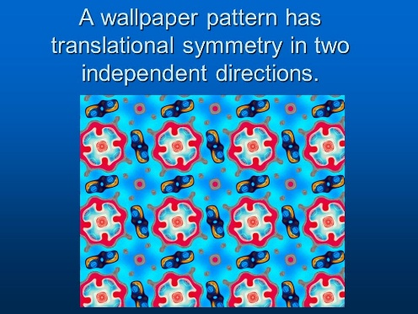

Bilateral Symmetry
Definition: A type of symmetry where the figure can be divided into two identical halves along one line (typically vertical).
Visual Example: Example: Human faces and animal bodies (e.g., cat, beetle).
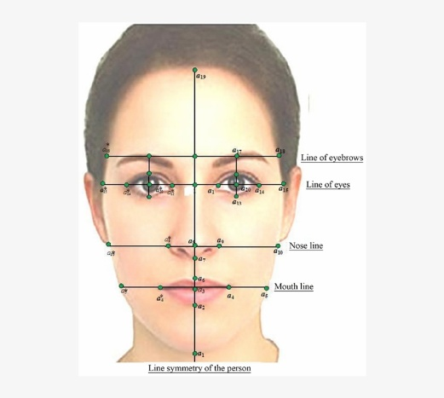

Radial Symmetry
Definition: Symmetry around a central point, where the parts are arranged like the spokes of a wheel.
Visual Example: Example: A starfish or a daisy flower.


Asymmetry
Definition: When a shape or design has no symmetry – the two sides are different.
Visual Example: Example: A tree with branches growing unevenly.

Tessellation
Definition: A repeating pattern of shapes that fit perfectly together without any gaps or overlaps.
Visual Example: Example: Honeycomb structure or Escher-style tiling.
🔗 Image Link: https://tse4.mm.bing.net/th/id/OIP.fSdjNk6eoAv35w4MUsA6SgHaFV?pid=Api

Geometric Transformation
Definition: A change in the position or size of a shape. Includes translation, reflection, rotation, and dilation.
Visual Example: Example: Moving a triangle to a new place on the grid without changing its shape.

