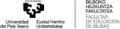Visual Aids: Global Filtration Systems
Below is a structured guide of what to include in your visual aids.
1. Biosand Filter (Used in rural areas globally)
● A tall container layered with gravel, sand, and sometimes charcoal.
● Removes sediments, bacteria, and some parasites.
● Used in over 60 countries (e.g., Nepal, Haiti, Kenya).
● Often made from cement or plastic barrels.
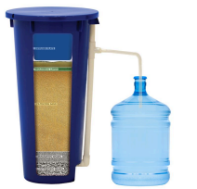
2. LifeStraw (Portable Personal Filter)
● A straw-like device that filters water while you drink.
● Used in emergencies, refugee camps, and outdoor survival.
● Removes 99.9% of bacteria and parasites.
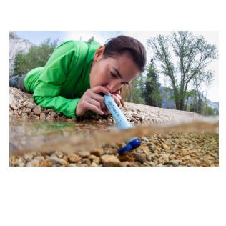
● No electricity or batteries needed.
3. Solar Disinfection (SODIS)
● Plastic bottles filled with water and left in sunlight for 6+ hours.
● UV-A rays from the sun kill bacteria and viruses.
● Used widely in Latin America and Sub-Saharan Africa.
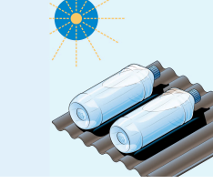
4. Ceramic Pot Filters
● Clay pots with tiny pores that block bacteria.
● Often mixed with sawdust and silver to enhance filtration.
● Common in Southeast Asia, Africa, and Central America.
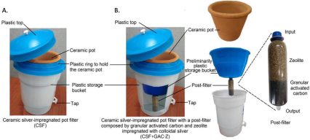5. Gravity-Fed Filters (e.g., in schools or clinics)
● Large containers with a filtration system inside (often ceramic + carbon). ● Clean water drips into a lower chamber.
● Often used by NGOs in humanitarian contexts.
