How to read punched cards
To explain this process, we will use the first operation as an example:
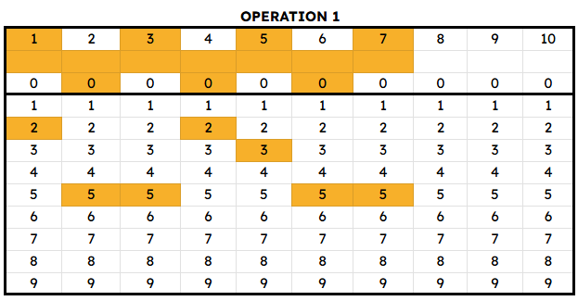
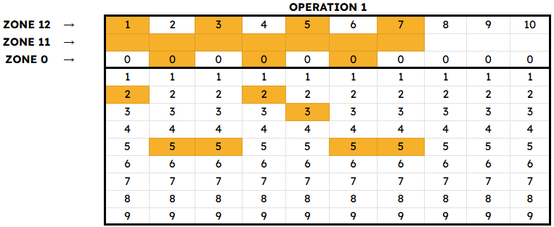
All punched cards have 2 sections, 3 rows that are called “Zones”, and then columns that represent characters:

Columns that represent characters

Each column represents a letter/number, and the blocks marked in yellow are the ones that are “punched”:

Each one of this parts of the columns represents either a number, a symbol or a letter. So, in this example we will have a text with 7 characters

And then, depending on which zones are punched, this will indicate whether the character is a letter, a number, or a symbol:
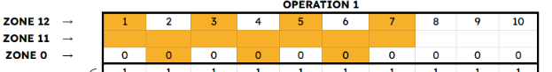
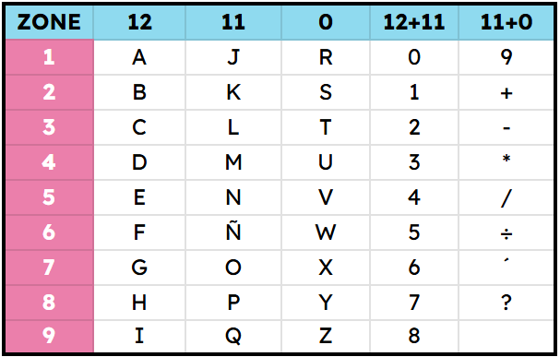
For us to know which one it is, we are going to need the reference card for decryption:

As you may see, in the first heater row, we have to step into the zones that are punched.
Let’s decrypt the first character. In order to do that, we will only work on the first column:
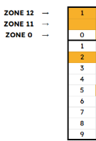
- Identify: Which zones are punched?
In this case, we may see that zone 12 and zone 11 are punched (marked in yellow).
- We step on the corresponding column in the card for decryption.
Once we have identified the punched zones, we need to locate the corresponding column on the card that provides their description, as illustrated below. For this character, we will work exclusively with the values displayed in that column.
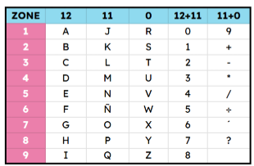

- Reveal the character
Finally, we have to identify which number is punched in the card column; in this case is the number 2:

Then, we step on the pink row of our decryption card on that number, and move our finger until we stop in the corresponding zone column:
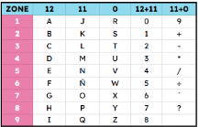

Finally, the intersection between the corresponding row and the zone column is going to give us the character, in this case, the number 1.
If you repeat this process with all the columns, you are going to decode the complete mathematical operation:
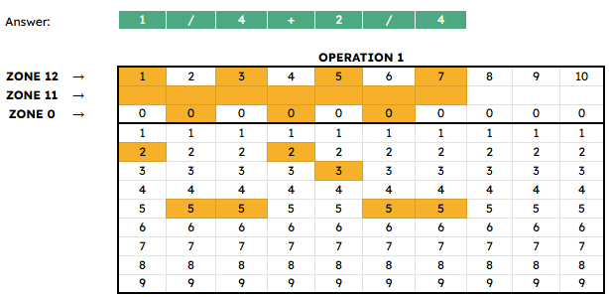
However, in this document, Punched card templates with complete answers, the teacher may find all the cards (both questions and answers) decrypted to make the process of revising students’ answers easier.

