
ISLAMIC MOSAIC
Relevant information:
Islamic mosaics, such as zellij or girih patterns, are intricate geometric designs commonly used in Islamic architecture to decorate walls, floors, and domes. These mosaics are composed of repeating shapes like squares, triangles, hexagons, and multi-pointed stars, often arranged in highly symmetrical and aesthetically balanced configurations. The patterns exhibit complex reflectional and rotational symmetries, sometimes up to 10- or 12-fold, and frequently incorporate proportions that approximate the golden ratio. In some historical examples, particularly from the 15th century, the designs even resemble quasi-periodic tilings similar to modern Penrose patterns.
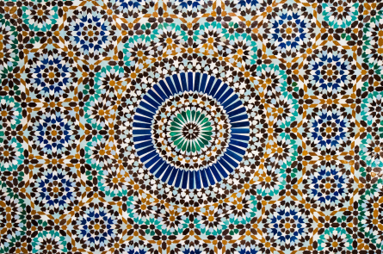
AFRICAN FRACTAL ARCHITECTURE
Relevant information:
African fractal architecture refers to traditional spatial designs found in various African cultures that exhibit fractal characteristics, such as self-similarity and recursive scaling. Villages, compounds, and pathways are often organized using repeated geometric shapes that appear at different scales within the same layout. These designs reflect a deep cultural logic where the structure of the whole is echoed in its parts, visible in circular or rectangular arrangements that nest within each other. The mathematical sophistication of these patterns lies in their use of geometric sequences, scaling ratios, and iterative spatial logic, long before formal definitions of fractals emerged.
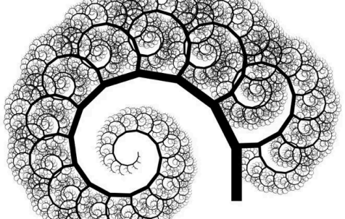
JAPANESE ORIGAMI PATTERN
Relevant information:
Japanese origami patterns are based on the traditional art of paper folding, where flat sheets are transformed into complex three-dimensional forms through a series of precise folds. These patterns are grounded in geometric principles such as symmetry, angle construction, and transformation. Many origami designs use repeated folds arranged in radial or grid-based layouts, creating tessellations, pleats, and star-like structures. The mathematics behind origami involves concepts like congruence, reflection, and geometric transformations, and often includes exact angle divisions such as 22.5°, 45°, or 90°. In more advanced patterns, origami can also involve algorithmic sequences and crease pattern analysis that reflect a high level of spatial reasoning and geometric control.
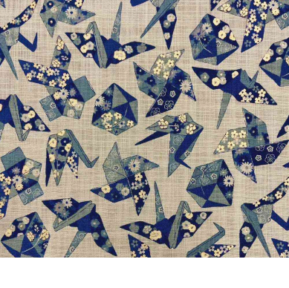
Mayan calendar segment
Relevant information:
The Mayan calendar segment is a symbolic and mathematical representation of time, developed by the ancient Maya civilization. It is often depicted as a circular arrangement composed of interlocking glyphs, each representing days, months, or cosmic cycles. The structure of the calendar is based on precise mathematical systems, including vigesimal (base-20) counting and cyclical patterns such as the 260-day Tzolk'in and the 365-day Haab’ calendar. These segments frequently display radial symmetry, repeated motifs, and geometric spacing that reflect the Maya’s sophisticated understanding of astronomy and timekeeping. The design integrates numerical patterns, rotations, and proportional divisions to encode cycles of time, ritual significance, and celestial movements.
