Role Model Biographies
1. Maryam Mirzakhani
Maryam Mirzakhani was a brilliant Iranian mathematician and the first woman to be awarded the Fields Medal, the most prestigious prize in mathematics. Her research focused on hyperbolic geometry, Riemann surfaces, and topologyareas that explore the shapes and surfaces of curved spaces. She developed new ways to understand how surfaces deform and repeat across space, which helped solve complex problems in theoretical mathematics. Mirzakhanis work is known for combining deep abstraction with strong visual intuition, and it has advanced our understanding of the geometric structures that underlie mathematical systems. She also broke significant gender barriers in a traditionally male-dominated field, becoming a global role model for women in STEM. Her legacy lives on through the many young scientists she continues to inspire.
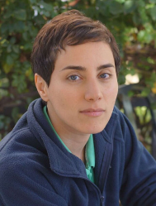
2. Florence Nightingale
Florence Nightingale is widely recognized as the founder of modern nursing, but she was also a pioneer in the use of data and statistical graphics. During the Crimean War, she collected medical data from field hospitals and used innovative visual tools like the polar area diagram (similar to a pie chart) to demonstrate the high rate of preventable deaths. Her clear and persuasive graphics convinced government officials to reform sanitation practices, saving thousands of lives. Nightingale was one of the first people to use data not just to describe the world, but to change it. She promoted evidence-based medicine, hospital design
based on statistics, and the education of women in science. Her legacy is an early and powerful example of how mathematical reasoning can be used for social good. 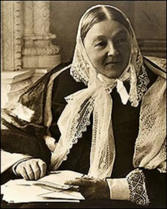
3. Katherine Johnson
Katherine Johnson was a trailblazing African-American mathematician whose work at NASA was vital to the success of the U.S. space program. She calculated flight trajectories, launch windows, and emergency return paths for many space missions, including the Apollo 11 mission that first landed humans on the Moon. Her ability to perform complex orbital mechanics by hand, before the use of electronic computers, earned her widespread respect. She was known for her precise logic and attention to detail, Page 1 Role Model Biographies which helped ensure astronaut safety and mission accuracy. Johnson's contributions were especially significant given the racial and gender discrimination she faced during her career. Her story, brought to light in the book and film 'Hidden Figures,' continues to inspire young people especially girls and minorities to pursue careers in science, technology, engineering, and mathematics.
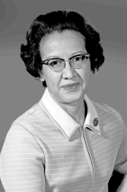
4. Yoko Shimizu
Yoko Shimizu is a Japanese biochemist, media artist, and science communicator who creates interactive installations that merge scientific concepts with artistic expression. Her work explores invisible natural phenomena such as chemical reactions, cellular behavior, and electromagnetic waves, transforming them into visual experiences that audiences can see and interact with. Trained in both science and design, Shimizu uses algorithms, sensors, and fluid dynamics to build artworks that react to human presence and environmental changes. Her installations have been featured in science museums, art galleries, and international festivals. She believes in breaking the boundaries between science and the arts to foster creativity and innovation, and her projects serve as an example of how interdisciplinary thinking can make scientific knowledge more accessible and emotionally engaging.
